Access Modifiers in java

There are two types of modifiers in java: **access modifiers** and **non-access modifiers.**

The access modifiers in java specify accessibility (scope) of a data member, method, constructor or class.

There are 4 types of java access modifiers:

1. private
2. default
3. protected
4. public

There are many non-access modifiers such as static, abstract, synchronized, native, volatile, transient etc. we will learn access modifiers.

Private access modifier

The private access modifier is accessible only within class.

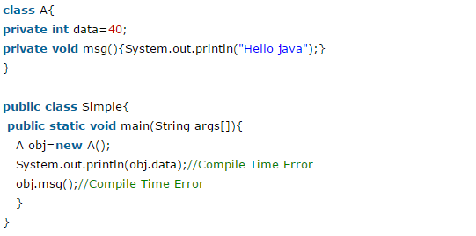

### Private Constructor

If you make any class constructor private, you cannot create the instance of that class from outside the class. For example:

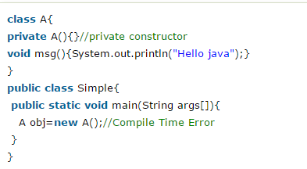

### Default access modifier

If you don't use any modifier, it is treated as default by default. The default modifier is accessible only within package.

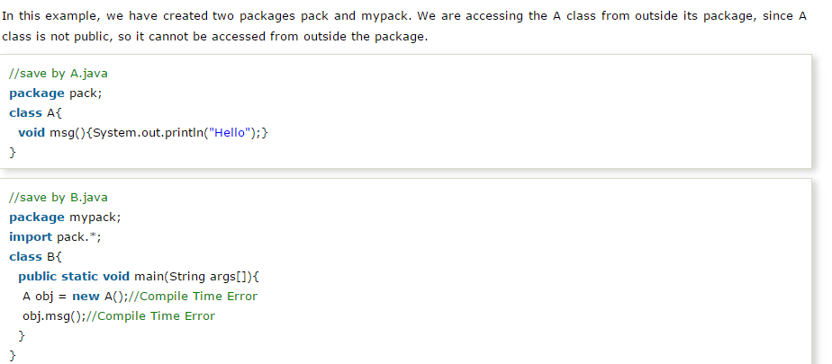

### Protected access modifier

The **protected access modifier** is accessible within package and outside the package but through inheritance only.

The protected access modifier can be applied on the data member, method and constructor. It can't be applied on the class.

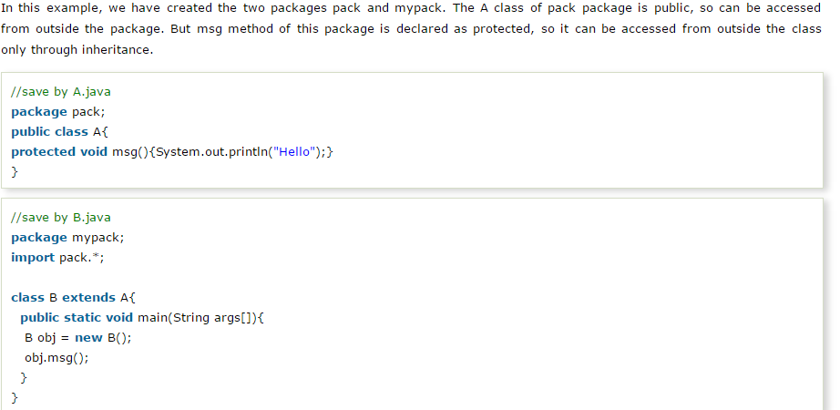

### Public access modifier

|  |
| --- |
| The **public access modifier** is accessible everywhere. It has the widest scope among all other modifiers. |

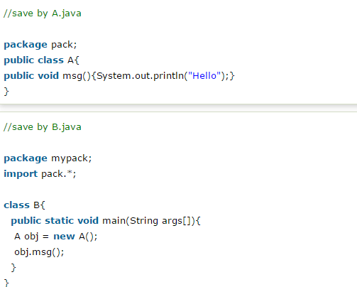

### Understanding all java access modifiers

